Website Review Report

Scanix and Roof Guard Websites used the same layout and style in most of the sections, like same header and footer section, same hero background image style in all pages and most of the sections repeated with same style and layout, both the websites should have consistent style and unique layouts related to the theme

1.Derma Aura

Website Link: https://dermatology-cosmetic-skin-clinic.vercel.app/
Issues
- Maintain consistent logo text styling in Dark Mode across all pages to ensure brand consistency, and refine the overall primary button layout while reducing the bottom background area for a cleaner appearance. 
- Review the website content and remove unnecessary or repetitive information, keeping only essential content to improve readability and help users understand the page flow more easily.
- The Home Page 1 and Home Page 2 hero sections currently have very similar layouts, so redesign the Home Page 2 hero section with a distinct structure.
home1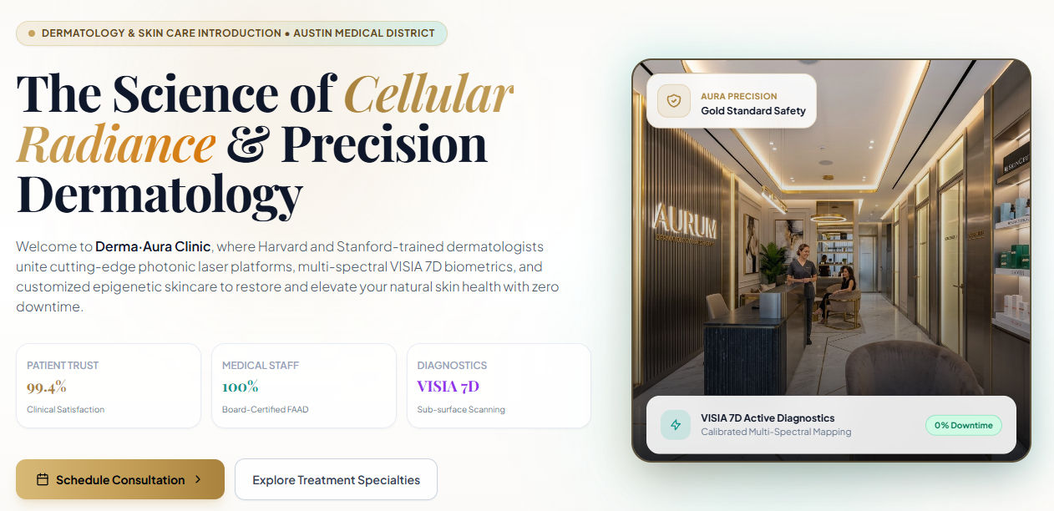
home2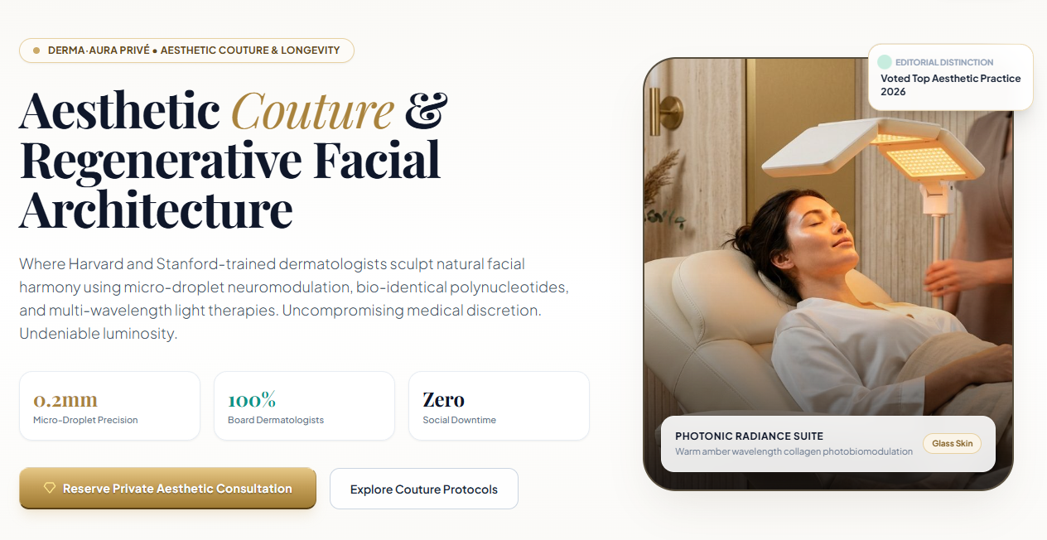
- On Home Page 1, improve the hover state of the Book Treatment button in the Skin Treatment Specialties & Featured Treatments section to ensure the button text remains clearly visible. 
- Maintain a consistent hero section height across all pages.
- On the Before & After page, improve the visibility of the Before and After labels displayed on images, and remove the unnecessary Rightwards Over Leftwards Arrow icon from the first section. 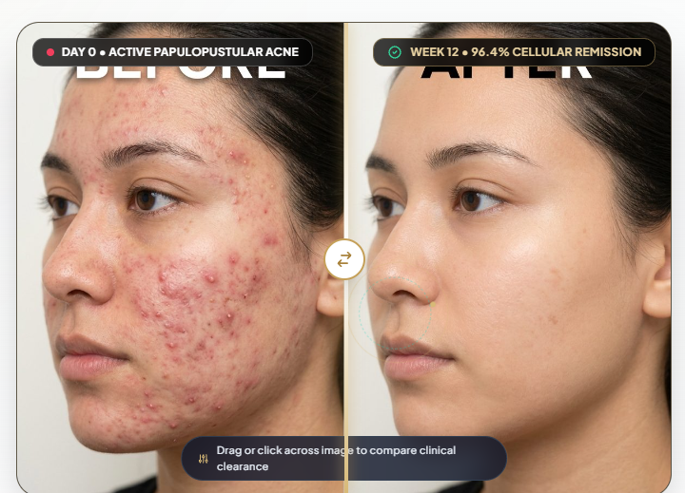
- Additionally, improve the visibility of green section heading labels throughout the website in Dark Mode to ensure sufficient contrast and readability.
- In the Admin Dashboard, remove either the Before & After Photos or B&A Gallery Showcase option, as both serve the same purpose. 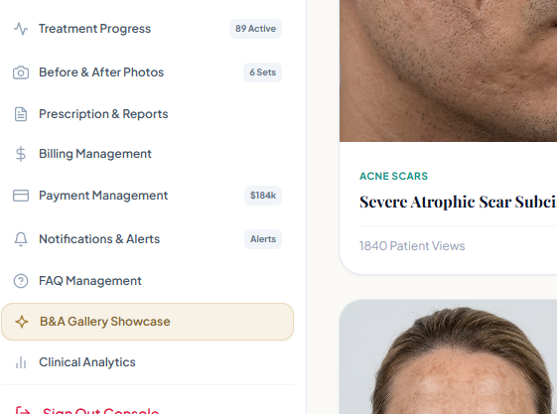
- About page – last section decrease the CTA label size
- Treatment page- second section image was cropped has to adjust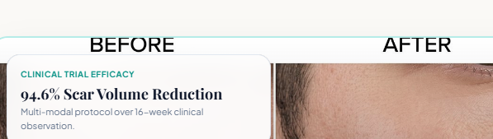
- Remove dashboard options in footer section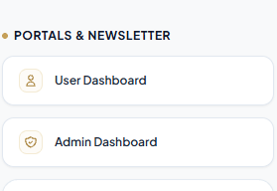
Responsiveness:
No issues

2.Physio Care

Website Link: https://physiocare-tau.vercel.app/
Issues
- The website should include a dedicated About Us page with sections such as Our Story, Our Mission & Values, Qualifications & Expertise, Clinic Facilities & Equipment, and Why Choose Our Clinic to build trust and clearly communicate the clinic’s experience and services.
- On the Contact page, add a relevant map section to help visitors easily locate the clinic.
- Throughout the website, use diverse, high-quality images that are relevant to each section’s content to improve visual appeal and help users understand the information more effectively.
- In the dashboard, make the sidebar sticky for easier navigation and use the correct LTR (Left-to-Right) icon to ensure proper functionality and visual consistency.
- In Light Mode, use white as the primary background and apply light grey or subtle shades of the primary brand color to alternate and highlighted sections, creating clear visual separation and improving readability across the website.
- Login page- brand name and welcome text as to be center aligned and decrease the font size and weight of welcome text
- 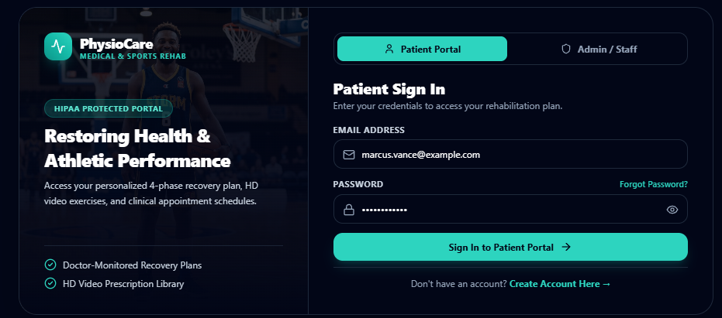
- Home page1- start your path section CTA style should be consistent

- Services and therapists hero image was same has to update 
- Therapists page-sub specialty section images were cropped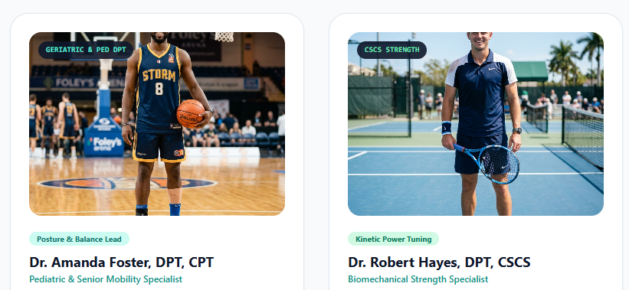
- Contact page replace with relevant image 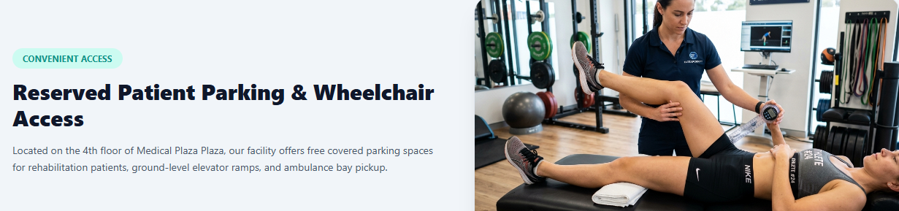

Responsiveness:
1. 1024px – hamburger icon is not working fine need to fix that issue

389.ferticare

Website Link: https://ferticare-tan.vercel.app/home2.html
Issues
- The Home Page 1 and Home Page 2 hero sections currently have very similar layouts, so redesign the Home Page 2 hero section with a distinct structure to create a more engaging and visually differentiated experience.
Home page1
home2
- On the Treatments page, replace the icons in the Our Primary Treatments section with relevant, high-quality images to help visitors better understand the treatments offered.
- Redesign the final CTA sections across all pages with distinct layouts to improve visual variety and encourage user engagement.
- Additionally, incorporate two more relevant sections across the website to provide clearer information about the treatments, pricing packages, and clinic location, ensuring a smooth and informative user journey.
- Throughout the website, use high-quality images that are relevant to the content to enhance visual appeal, improve clarity, and create a more professional and cohesive design.
- Login page- remove the demo credentials
- Home page2-fertility specialists section add relevant image

Responsiveness:
No issues

390. homeo clinic

Website Link: https://homeopathy-azure.vercel.app/
Issues
- Maintain a consistent header layout across all pages by placing the primary CTA button at the end of the navigation and ensuring the logo remains visually consistent in both Light and Dark Modes.
- Use the primary brand color consistently across both themes to strengthen brand identity and maintain a cohesive visual experience.
- Throughout the website, incorporate high-quality, relevant images that align with the content of each section to improve clarity and visual appeal.
- On Home Page 1 and Home Page 2, add two additional sections, such as Why Choose Our Clinic, How It Works, and an FAQ section, to provide essential information and help visitors better understand the clinic’s services.
- On the About page, use relevant, high-quality images in the Leading Experts section to highlight the team’s expertise and build trust.
- Finally, review the footer and ensure that all Quick Links are relevant to the website, clearly organized, and connected to the appropriate pages for easier navigation.

- Home page1- hero image can use a background image or and attractive image for consistent look
- Home page2- hero section CTA size should be consistent
- About page- leading expert section image alignment should be consistent
- About page- our specialist section text in the grids has to be aligned
- Blog page- second section organize the empty space properly
- Book appointment was showing error page has to update
Responsiveness:
In 360px – home 2 page – below the hero section – cta has a padding issues.


scanix

Website Link: https://scanix-kappa.vercel.app/
Issues
- Across the website, maintain a consistent height and corner radius for the Theme, RTL, and primary CTA buttons in the header to ensure visual uniformity and a polished navigation experience.
- The Home Page 1 and Home Page 2 hero sections currently have very similar layouts, so redesign the Home Page 2 hero section with a distinct structure to improve visual variety.
home1
home2
- On Home Page 1, move the final CTA section to the bottom of the page so it serves as the concluding call to action, and add two more relevant sections to both Home Page 1 and Home Page 2 to provide more complete information and improve user engagement.
- Additionally, replace the FAQ page link in the header with dedicated Appointments and Results & Reports pages to make these essential features easier to access and provide a more user-friendly navigation experience.
- Home page1- patient reviews section heading can be center aligned
- About page – stats should be placed in the second section

Responsiveness:
No issues

talkthera

Website Link: https://talkthera.vercel.app/
Issues
- Rework the Speech & Language Therapy Center website with a clear, professional, and user-friendly structure that helps visitors quickly understand what speech and language therapy is, the services offered, the specialist’s qualifications and expertise, and how to get in touch.
- Organize the website into detailed, easy-to-navigate pages covering the center’s overview, speech and language conditions treated, therapy services, treatment process, specialist profile, and contact information.
- Use relevant, high-quality images throughout the website to support the content and make each service easier to understand. Present essential information with clear headings, concise descriptions, and prominent CTAs such as Book an Appointment, Explore Our Services, and Contact the Specialist.
- Ensure that users can quickly identify the support they need, understand the therapy process and expected treatment timeline, and easily find the appropriate service or contact option.
- Maintain a consistent visual design, intuitive navigation, and a logical content hierarchy to improve readability and help users reach their goals with minimal effort.

- Overall ,same images are repeated in all pages has to update with professional and relevant ones
- Fav icon was missing in the web browser
- Nav bar- primary CTA was missing add relevant one
- CTA visibility should be consistent
Home1-
Responsiveness:
In 360px,768px - Home 2 page – hero section – top has a padding issues.
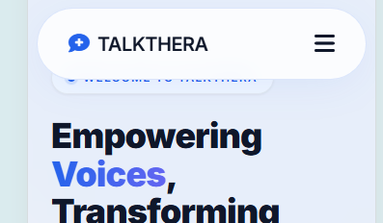

spinecare

Website Link: https://chiropractic-spine-care-clinic.vercel.app/
Issues
- The Home Page 1 and Home Page 2 hero sections currently have very similar layouts, so redesign the Home Page 2 hero section with a distinct structure to improve visual variety and create a more engaging user experience.
home2
- Maintain a consistent hero section height across all pages to ensure visual uniformity and a balanced layout.
- On the Services page, replace the icons in the Core Services section with relevant, high-quality images to help visitors better understand the spine care services offered.
- On the Gallery page, improve the text visibility on image hover by ensuring sufficient contrast between the primary color text and the background.
- Additionally, redesign the final CTA sections across all pages with distinct layouts to avoid repetition, improve visual appeal, and encourage visitors to take the next step, such as booking an appointment or contacting the specialist.

- Home page1- last section CTA size should be consistent
- Home page2- targeted relief section text has to be aligned in the grids
- Gallery page- small text on image has contrast issue
- Contact page- second section text in the grids has to be aligned

Responsiveness:
No issues

orthosmile

Website Link: https://orthodontic-and-braces-clinic.vercel.app/
Issues
- The Home Page 1 and Home Page 2 hero sections currently have very similar layouts, so redesign the Home Page 2 hero section with a distinct structure.
home1
home2
- overall change the primary color button text color for better visibility.
- In dark mode, use black as the primary background and dark grey/subtle color of primary color for alternate or highlighted sections to improve visual separation and readability.
- Home page2- second section text in the grids looks heavy has to be updated
- Dentists page- specialists section add profile images has to update
- Pricing page- simple process section the line should be properly aligned
- Dashboard page- brand name was missing has to update
Responsiveness:
In 1024px – footer section – text has a layout issue need to fixz that.
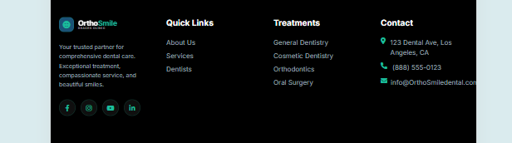

sleepwell

Website Link: https://sleepwell-sigma.vercel.app/
Issues
- On the header move the blog page link before the contact page link and overall maintain a consistent hero section height.
- on home page 1 move the final CTA section to the last.
- Home page1- hero image should be more attractive with a background image
- All non home page hero images was not clear has to update with clear images
Responsiveness:
In 360px – contact clinic page – email container has text layout issue.


serenity

Website Link: https://serenity-ruddy-delta.vercel.app/
Issues
- In home page 1 & 2 rather than just relaying on the content try adding more images with more detailed information for better visual storytelling.
- In the header Remove the current icon, Replace it with a proper, relevant RTL icon or simply keep the “RTL” text without an icon.
- In resources page add appropriate images relevant to the content for all the containers.
- Overall do not repeat the same images for different content.
- Maintain button consistency with appropriate height and width across all the pages.
- Nav bar- add login page with secondary CTA
- Home page1- four simple steps section remove the line below the grids
- Home page1- client journeys section decreases the label size

Responsiveness:
In 360,768,1024px – when user clicks the hamburger icon the hero section moves downwards.
In 360px – dashboard page – messages section – text has a layout issue.
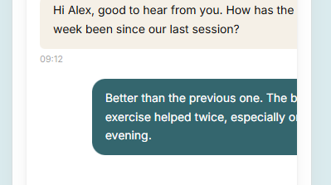

Dry Shield

Website Link: https://dryshield.vercel.app/
Issues
- the Basement Waterproofing & Foundation Repair Company website to make it professional, visually engaging, and focused on helping customers quickly identify and resolve their basement and foundation issues.
- On both Home pages, remove the icons next to section headings and ensure each page includes at least six meaningful sections covering common problems, services, warning signs, the repair process, customer benefits, and testimonials.
- Make Home Page 2 more effective at converting visitors into customers with clear service information, relevant visuals, and prominent booking CTAs.
- On the About page, remove the watermark from the images in the “Meet Our Team” section.
- On all Service pages, style the primary CTA consistently and clearly display the service cost and time required wherever applicable.
- Maintain a consistent Hero section height, spacing, and relevant background-image style across all inner pages, while keeping the Home pages visually engaging.
- Use high-quality, relevant photographs of basement water damage, foundation repairs, waterproofing solutions, and completed projects.
- Maintain consistent branding, readable content hierarchy, and balanced spacing throughout.
- Make it easy for users to identify their problems, explore suitable services, understand the process, and book an inspection or request a quote through clear, prominent CTAs.

- Gallery page- featured project section text on image was cropped

Responsiveness:
No issues

pureair

Website Link: https://mold-remediation-air-quality-testin.vercel.app/
Issues
- Maintain a consistent height and corner radius for the Theme, RTL, and primary CTA buttons in the header to ensure a uniform and polished appearance.
- Ensure the logo mark remains identical in both Light and Dark Modes to maintain brand consistency.
- The Home Page 1 and Home Page 2 hero sections currently have very similar layouts, so redesign the Home Page 2 hero section with a distinct structure to improve visual variety.
- Maintain a consistent hero section height across all pages for a balanced visual experience.
- On Home Page 1, reduce the excessive top spacing in the hero section, and remove the scroll option from the What We Do section, replacing it with a more user-friendly layout for displaying the content.
- In the Meet the Experts section, eliminate unnecessary empty space within the containers, and reduce the bottom spacing in the left container of the Client Stories section to improve alignment and balance.
- Throughout the website, use high-quality, relevant images that match each section’s content to enhance visual appeal, improve clarity, and create a cohesive user experience.
- Home page1 –hero image can be replaced with relevant one
- Home page1- what we do section container size has to be consistent
- About page- last section text has contrast issue has to update
- Services page- all services section icon should have proper alignment
- Blog page hero image text has contrast issue
- Blog page- writers section text has to be aligned

Responsiveness:
In 360px – dashboard page – analytics section – content out of container issue.
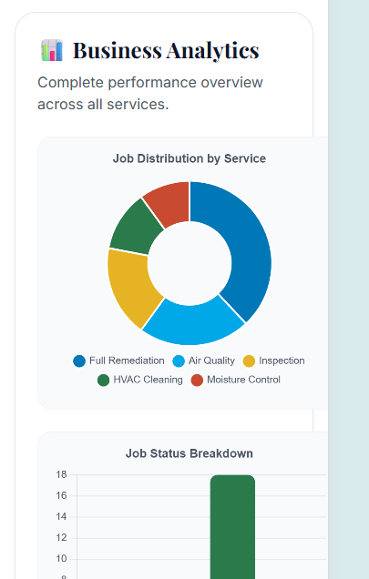

aquapure

Website Link: https://home-one-black.vercel.app/
Issues
- Across the website, position the Book Now CTA button at the end of the header navigation to maintain a clear and consistent layout.
- In the last section of every page, provide adequate padding for the text in input fields to ensure proper spacing, alignment, and a comfortable user experience.
- On the Product page, improve the visibility of the Field Execution text displayed over the image by adjusting the text color, background overlay, or contrast for better readability.
- On the FAQ page, align all FAQ containers consistently with the left edge consistent with the section heading to create a clean, structured layout and improve visual alignment.
- Use font weight up to 600 for headings and 400 for paragraphs to maintain a clear hierarchy.
- Home page2- hero section text has contrast issue has to update
- Home page2- plumbing pathology section text on image has contrast issue
- Solutions page- second section text on image has contrast issue
- Products page- field execution section text on image has contrast issue
- Products page- commercial quality section text label on image has contrast issue
- Pricing page- uncompromising quality section text on image has contrast issue

Responsiveness:
In 360px – about page – above the footer section – text has a layout issue.


roofguard

Website Link: https://roof-cyan-two.vercel.app/
Issues
- Across the website, maintain a consistent height and corner radius for the Theme, RTL, and primary CTA buttons in the header, and ensure proper alignment between the logo mark and brand name.
- Maintain a consistent hero section height across all pages to create a uniform and balanced visual experience.
- Use different, high-quality images that are relevant to each section’s content, avoiding repetitive imagery throughout the website.
- On Home Page 1, remove the unnecessary plus icon from the Common Questions section containers to maintain a cleaner appearance.
- On the FAQ page, ensure equal top and bottom padding within the answers in both the Residential and Commercial sections for consistent spacing and readability.
- On the Contact page, add a dropdown indicator to the Select Service Needed input field in the Free Estimate section to clearly communicate that users can select a service from the available options.

Responsiveness:
In 360px – about page – our core mission section – text has a layout issue.

In 1024px – footer section – text has a overlapping issues need to fix that properly,
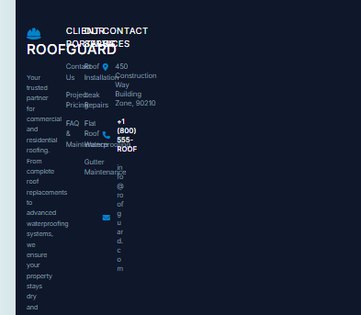

lumewood

Website Link: https://modular-wardrobe-cabinet-maker-proj.vercel.app/
Issues
- Maintain consistent left and right padding in the header across all pages, and ensure the logo has the same design, size, and styling in both the header and footer.
- The Home Page 1 and Home Page 2 hero sections currently have very similar layouts, so redesign the Home Page 2 hero section with a distinct structure to improve visual variety.
home1
home2
- Maintain a consistent hero section height across all pages for a balanced and cohesive appearance.
- On Home Page 1, improve the visibility of the hero section label text in Dark Mode by ensuring sufficient contrast against the background.
- On Home Page 2, align the section headings and content to the left, and apply consistent left alignment to headings and content in other sections wherever appropriate to improve readability and visual structure.
- On the Design Gallery, Pricing Guide, Blog, and Contact pages, convert relevant actions into clearly visible CTA buttons to improve usability and encourage user engagement.
- On the Contact page, improve the visibility of the dropdown options in the Start the Conversation section in Dark Mode to ensure clear readability and accessibility.
- For Dark Mode, use black as the primary background and dark grey or subtle shades of the primary brand color for alternate and highlighted sections to create clear visual separation.
- For Light Mode, use white as the primary background and light grey or subtle shades of the primary brand color for alternate and highlighted sections to maintain readability and visual consistency across the website.
- Header and footer section brand logo has to be consistent
- Home page2- last section CTAs has contrast issue on hovering
- Design gallery hero section left align the content
- Pricing guide page- all section headings should be left aligned

Responsiveness:
In 360px,768px,1024px– rtl and dark theme icons are already in the nav bar need to remove from the hamburger menu list.

